**Preliminary findings regarding education level for each job category:**

There are 167,279 rows.

Unfortunately, I noticed that most people listed in this report did not enter much information. 156,183 of them entered “NA” for Education Level Required. That’s 93.37% of them! That means that only 11,096 entered data, which is only 6.63%, not very many.

But anyway, there are 11904 distinct JOB TITLEs. There’s also JOB_TITLE_SUBGROUP (nine of those) and PREVAILING_WAGE_SOC_TITLE (382 of those) and PREVAILING_WAGE_SOC_CODE (411 of those).

The JOB_TITLE_SUBGROUP has the following nine subgroups:

Assistant professor

Attorney

Business analyst

Data analyst

Data scientist

Management consultant

Software engineer

Teacher

64000

(64000 is apparently a Business Analyst, so I’m going to consider them to be the same for my purposes.)

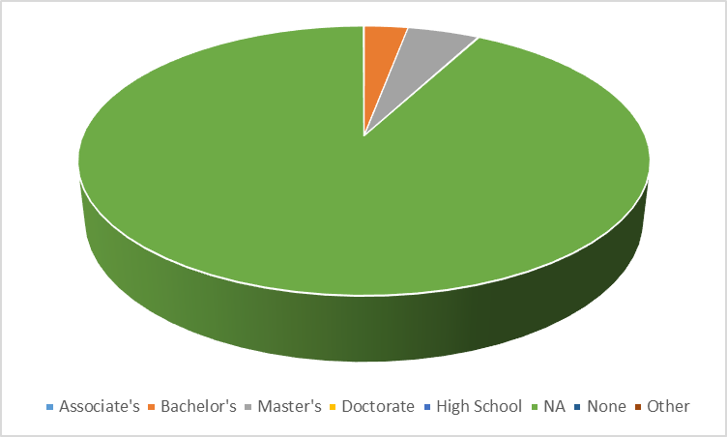I’ll look at the Software Engineers first (since I am one). These are the Education levels that were reported by Software Engineers:

|  |  |
| --- | --- |
| Associate's | 17 |
| Bachelor's | 2932 |
| Master's | 4809 |
| Doctorate | 82 |
| High School | 1 |
| NA | 91480 |
| None | 19 |
| Other | 24 |

Again, a great majority are reported as NA. So, let’s take out the NAs. This will give us a much better analysis:

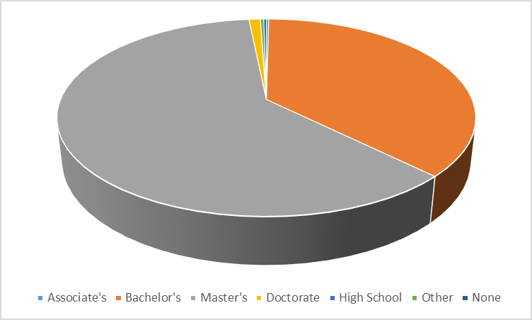You can see that a majority of the Software Engineering jobs require a Master’s degree, 61% of them. A Bachelors is required for 37% of them. Together that is 98%. A Doctorate is required by 1.04%, and the rest, including other, are all under a third of a percent. So, a Masters is the best academic goal for Software Engineers. (By the way, this proves that all "other" ways of becoming a software engineer, such as trade schools or coding bootcamps, are not worth the cost.)

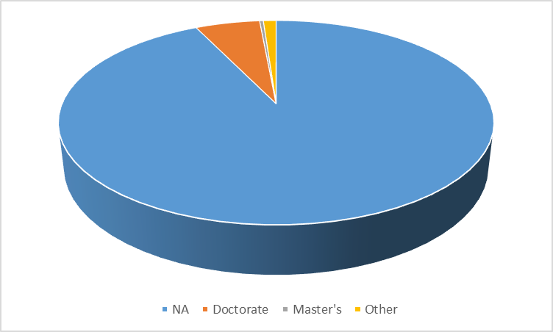Assistant Professors tend to require more education. There are 18867 of them. Again, 17,512 of them reported NA, which doesn’t help:

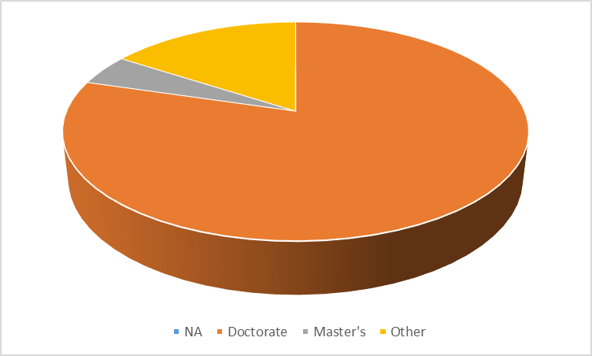If we take out the NAs, it makes more sense. Out of the 1354 non-NA values, 1078 of them require doctorates, which is 79.6%. A Masters is required for 4.6% and Other is 15.8%. So, in this case, a Masters would not be the academic goal if you wanted to become an Assistant Professor. (This is the opposite of Software Engineers.)

The education requirement for attorney didn't have enough data to be statistically significant. Out of the 1489 attorneys, 1414 of them had NA in that column. 60 of them had "other" in that column, leaving only 9 masters, 4 doctorates and 1 bachelors. Only 14 of the attorneys had any specific data, which is less than 1%. So, there's nothing statistically significant there. (I happen to know that anyone who passes the bar is an attorney. Law Schools help tremendously with you passing the bar but are not required. And most law schools require a bachelors before you are admitted. So, by that logic, most attorneys have bachelors, but they don't have to.)

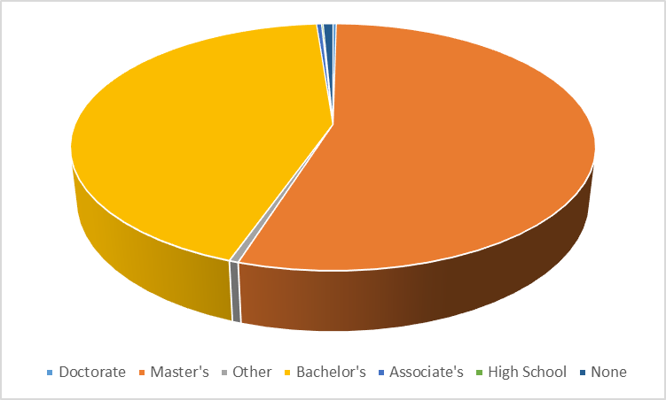Business Analysts have much more definitive answers. There are 27812 of those. 26982 of them were NA (which is 97%). The biggest response is those with a Masters degree, which is 453 (1.6%). 360 of them have Bachelors (1.3%). The rest are less than 0.02% each.

Data Analysts are 3840. 3715 are 97% NA. Masters is 76, which is 1.98%. Bachelors is 49, which is 1.28%.

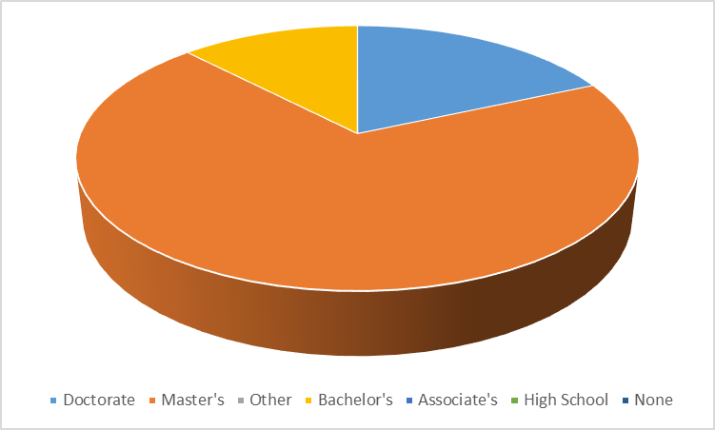Data Scientists are 1227. 1178 (96%) of those are NA, 34 (2.77%) are masters, and 9 (0.73%) have doctorates. Only 6 (0.49%) only have Bachelors. So, it’s clear that to be a scientist, you don’t need to have a doctorate! Most of the non-NA respondents are Masters.

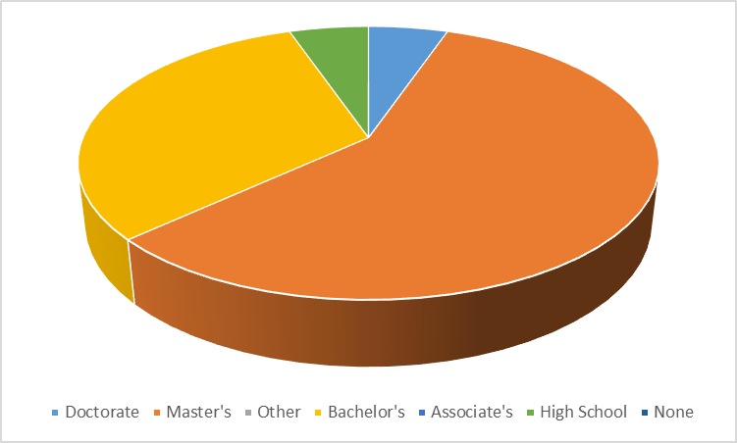There are 770 management consultants. 751 (98%) are NA. 11 have Masters, which is 1.43%. Six of them have Bachelors, which is 0.78%. The rest are all under 0.13%.

There are 13,912 teachers. 13.153 said NA for education level, which is 94.5%. Bachelors are the highest non-NA category, which is 584 (4.2%). 96 (0.7%) have Masters. 64 (0.46%) is other, and the rest have less than 0.029% each.

